- Spring Newsletter  Manorwood Owners’ Association Board and Officers  President — Josh Beloit  Vice President — Jon House  Treasurer/Secretary — Linda Dement  Secretary — VACANT  Directors —  Heidi Burkheimer  Aaron Grenlund  Jennifer Reed  Mark Thurber  Chad Brummer  Committees  (volunteers needed!)  Architectural Control — Jennifer Reed  Greg Dement  Abe Rossy  Mark Thurber  Clubhouse — VACANT  Pool —  Linda Dement  Heidi Burkheimer  Jon House  Grounds — Mark Thurber  Sports courts — VACANT  RV Lot — Josh Beloit, Greg Dement  Activities — Stephanie Benson, Linda Dement  Welcome Wagon — VACANT  Website — VACANT  Nominating — VACANT  Clubhouse coordinator — Linda Dement  JC Higgins & Associates  Association Management Company  802 39th Ave SW, Puyallup 98373  Association Manager: Lorne Martin,  253-841-0111, Ext. 120,  lorne@jc-higgins.com  - Contact Us  Manorwood Owners’ Association  2716 Manorwood Drive SE  Puyallup, WA 98374  Email  manorwoodhoa@gmail.com  Website  www.manorwood.org  Upcoming Board Meetings:  Located at  2716 Manorwood Drive SE  April 23 6:30  May 28 6:30  April – June  Dates to Remember  *Federal holiday  April 22 Earth Day  May 7 Teachers Day  May 10 Military Spouse Appreciation Day  May 12 Mother’s Day  May 27 Memorial Day*  June 7 National Donut Day  June 14 U.S. Flag Day  June 16 Father’s Day  June 18 Last Day of School  June 19 Juneteenth*  June 20 June Solstice | Manorwood Homeowners Association    Welcome New Members –  Jeanette and Freddie – Lot #7  Sarah and Scott – Lot #73  Updates from your Manorwood Board  Pool repairs  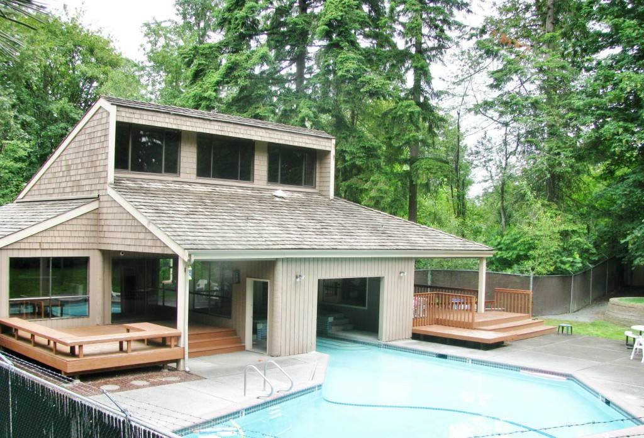  Last season, we discovered a leak in the pool and researched where it was coming from. We are pleased to announce that we accepted a bid for the repair of the three skimmer baskets and repair the leak near the drain. We anticipate the work will be finished before pool season begins!  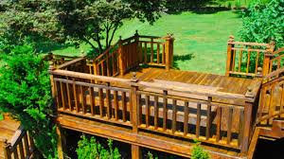  Deck Updates  Our clubhouse deck is needing some TLC and your Manorwood board has had some bids and contractors come out to price a replacement deck. This is an ongoing project and we anticipate this replacement will occur after the 2024 swim season.  Swim Season Updates  Manorwood Pool opens in May and we can’t wait to kick off the summer season. Be sure to have your dues paid off to ensure access to the pool and clubhouse.  ManorwoodPool - Quick reminders  - Pool hours are 12 a.m. – 9 p.m.  - Pool Capacity: 25.  - No lifeguard is on duty. Pool attendants are not lifeguards.  - Pool is for Manorwood Division 1 residents/tenants and  - their guests ONLY.  - Pool attendants have full authority to enforce rules.  - Residents and tenants must sign in, even if there is no attendant.  Board Secretary Needed  Are you interested in learning more about the Manorwood board and being part of your community- become the Manorwood secretary for our board. Commitment is a monthly board meeting where notes are taken, prepping the agenda monthly, and emailing the draft minutes for review/approval by the board. Average time commitment is 3-4 hours a month.  Committee Members needed    Our MOA is looking for a few good folks. Our committees and board are run by volunteers and we need a few more. We currently need help with some of the following roles:  Welcome Wagon - greet new members when they move in  Nominating Committee - look for folks to run for the board  Sports Court – help setup and maintain the basketball and tennis courts  Clubhouse Coordinator – help with the member rentals.  Pool Attendants  Youth 14 and older can apply to be a pool attendant at the Manorwood Pool. The pool committee will send out the request for applications soon – please submit your application to manorwoodhoa@gmail.com for consideration.  All pool attendants will need to attend an orientation on employment expectations, training on chemical management and other housekeeping items.  Upcoming Events    Keep your calendars open for the Manorwood Fourth of July parade and potluck. The parade usually starts at 11:30 – with everyone meeting up at 11 to get ready and potluck to follow.  Reminder – these fireworks are illegal in Washington State    https://www.wsp.wa.gov/wp-content/uploads/2021/05/Fireworks-Stand-List-Legal-and-Illegal.pdf  Pool rules updates    The pool committee met with the board and updated the Manorwood Pool Rules for the new season starting in May 2024.  Failing to follow these rules could result in loss of pool/clubhouse privileges.  (1) Pool is for Manorwood Division 1 residents/tenants, children living in the residence, and their guests for personal use ONLY.  (2) By signing in you agree to follow all the rules contained in this document.  (3) Each homeowner/tenant is allowed a maximum of 5 guests.  a. Children who are 13 to 17 years old may sign in only 1 guest who is 13 and older. They cannot bring children 12 or younger to the pool.  (4) Anyone refusing to obey the pool rules is subject to removal from the premises. Pool attendants have the full authority to enforce the Manorwood Pool Rules and Safety Guidelines.  (5) ID is required to enter pool area and must be from a homeowner or tenant. Acceptable forms of ID are:  a. WA State ID (driver’s license/permit) or Federal ID (military)  b. School ID (Middle School, High School, College)  (6) Age Restriction Rules:  a. Children 12 years old and younger must be accompanied by a responsible adult (parent, tenant, older sibling) 18 or older, and the adult must be at the pool or pool deck at all times when the child uses the facility.  b. Children 13 to 17 years old cannot be alone at the pool. They must be with at least one other person 13 years or older (excluding the pool attendant). As stated in (2), children 13 to 17 cannot bring children 12 or younger to the pool.  (7) The following is strictly prohibited:  a. Running or participating in horseplay  b. Headfirst diving, cartwheels, backflips, and any other gymnastic-like maneuvers  c. Possession/use of tobacco, vaping products, or other drugs  d. Anyone with a communicable disease or anyone who has been ill with vomiting or diarrhea within the previous two weeks  e. Food or drink in the pool (must remain at least 4 feet from the pool edge)  f. Glass in the pool area (for example, bottles, plates)  g. Animals (unless ADA-approved service animal)  h. Frayed street clothes  (8) Alcohol may be consumed in moderation  (9) Everyone must have a cleansing shower (at home or at the Clubhouse) before entering the pool and upon reentry from using the bathroom.  (10) Diapers must be shielded by protective covering to prevent contamination; diapers must be changed at designated diaper change area.  (11) A telephone and a first-aid kit for emergency use are in the Clubhouse kitchen.  (12) Anyone with seizure, heart, or circulatory problems should swim with a buddy.  (13) Audio equipment, battery-operated only, is allowable if the sound level does not disturb others.  (14) Patio furniture in the pool area shall not be removed from the pool area. Return it to the storage area before leaving.  (15) It is the residents and guests’ responsibility to clean up after themselves. Pool attendants are not responsible for personal debris.

